**Website Project Proposal**

1. **Project Site Title**

Website for Sigma Alpha Mu

1. **Client**

Sigma Alpha Mu (Gamma Lambda)

1. **What the idea is?**

Sigma Alpha Mu (Sammys) is a social fraternity here at NIU. Currently, their website is not working anymore and they previously used Wordpress to make their website. The idea is to make basic website that provides information about the fraternity.

1. **What will your site do and in what way provides service or solves a problem?**

Our website will provide information about the fraternity’s history, their current news and events, FAQ section for prospective members and parents and section for current members and alumni.

1. **Describe the customer base?**

The customer base will be prospective members, parents and alumni.

1. **Describe a visitor using your site**

Users can find current events, history of the chapter & fraternity, FAQs, a members login and alumni sections. The visitor will be able to learn a little about the fraternity its core values, members and history in order to peak curiosity and learn about current events to participate in.

1. **Describe your project road map.**

The project road map currently is, updating the current website to be more user friendly and better looking. First we will make the homepage, then will will go and create each individual page. After all the pages are created we will link them all together,then add the contact that  Sigma Alpha Mu provides to use. Then we will push the pages on github.

1. **How far along is the idea development?**

We have an idea of what we want the website to look like, we also have the content to populate the website coming from Sigma Alpha Mu.

1. **Site map**

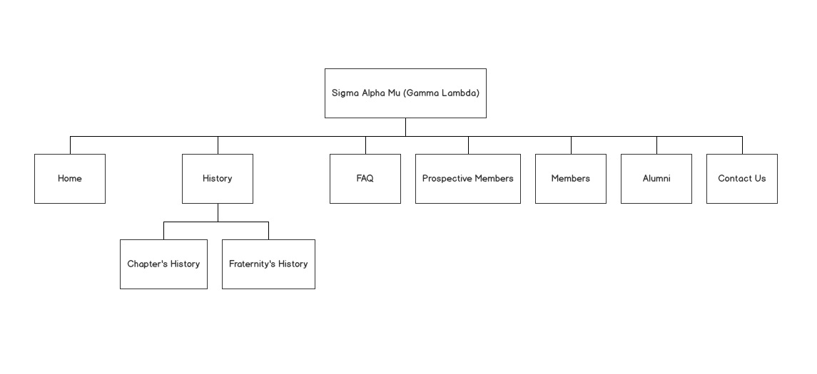

1. **Inspiration site**

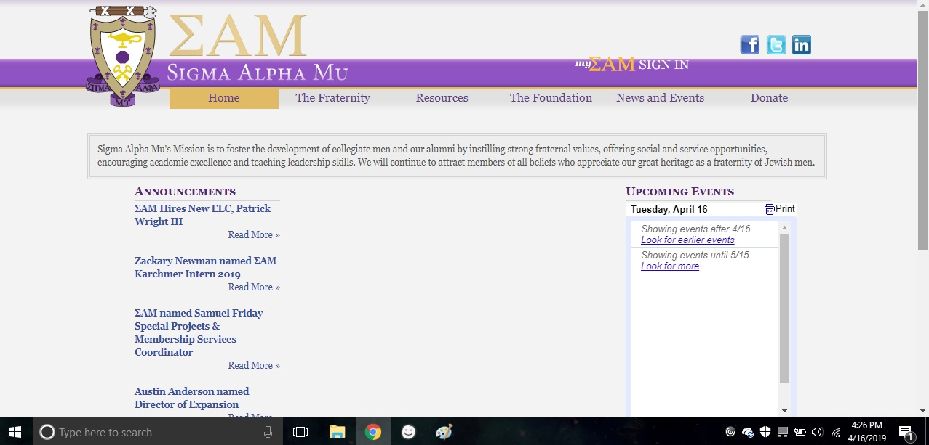

1. **Color combination**

Chapter colors: Purple, white, alternative black

Fraternity national colors: Purple, white, golds

1. **Wireframe and Mockup**